Report week7

1.

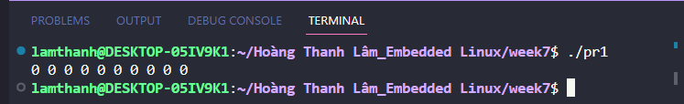

First, run progaram1 and display there is no value of the shared memory.

Next, write data in the shared memory by using program 2.



Last, run program1 and confirm the value is written in the shared memory.

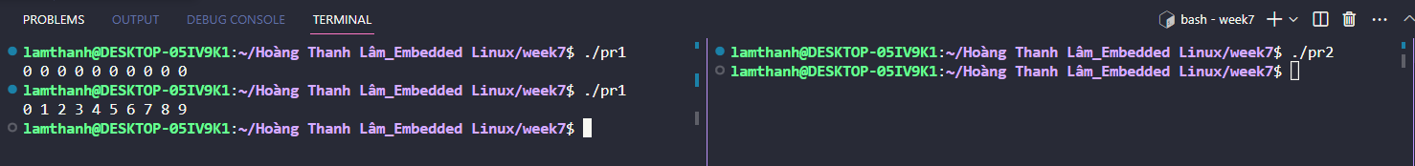

2.

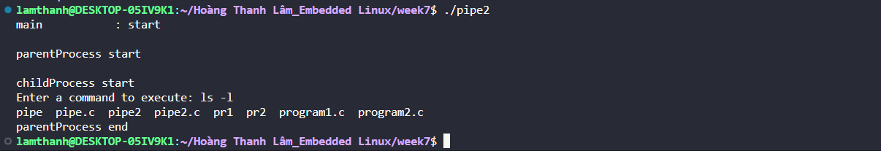

The program forks a child process using the fork function. If the fork succeeds, the program enters the child process. In the child process, the program reads the command line argument passed from the parent process through the pipe using the read function. The child process then terminates the string and switches the file descriptor for the pipe output to a standard input using the dup function.

In the parent process, the program prompts the user to enter a command to execute. It then writes the command to the pipe using the write function and checks for errors. Finally, the program closes the file descriptors for the pipe, waits for the child process to finish using the waitpid function, and prints a message before exiting.

